

**Kashmir Journal of Science**

<https://kjs.org.pk> **ISSN: 2958-7832**

*Kashmir Journal of Science (2024), 3(3): 1-11*

**Research Paper**

**Morphological characterization of potato (*Solanum tuberosum* L.) germplasm from Azad Jammu and Kashmir**

**Sidra Nasar*1, Hajira Sabir1, Saima Khan1, Shamshad Aziz1, Ansar Mehmood2**

*1Department of Botany, University of Azad Jammu and Kashmir Muzaffarabad*

*2Department of Botany, University of Poonch Rawalakot AJK*

**\***Corresponding Author Email: [sidnasar88@gmail.com](mailto:sidnasar88@gmail.com)

**ARTICLE INFO**

**Article history:**

Received: 11 November 2024

Accepted: 18 November 2024 Available online: 03 December 2024

**Keywords:**

Food security;

Potato varieties; Agromorphological traits; Himalayas;

Tuber yield.

**Abstract**

Current study was designed to investigate the diversity of agromorphological traits of five potato varieties from the state of Azad Jammu and Kashmir. The investigated traits included qualitative as well as quantitative attributes including stem, leaf, tuber and yield traits. The data was collected from 05 potato cultivation sites of AJK including Leepa, Shounthar, Taobut, Sudhan Gali and Kala Mula. The investigated varieties showed significant variations in the qualitative traits including growth habit, stem and leaf color as well as tuber and flesh colors. The results revealed that average values of plant height were 58.28 cm, stem thickness 5.66 mm, leaf length 15.66 cm, leaf width 10.44 cm, leaflet number 6.8, flowering time 61 days, tuber length 8.64 cm, tuber width 4.16 cm, and tuber thickness was 5.78 cm, whereas average tuber yield per plant was 390.6 g. Results revealed that the investigative varieties exhibit significant morphological variations which reflect genetic diversity as well as adaptation of these varieties in diverse agro-climatic conditions of the region. The findings of current study provide baseline information about the potato germplasm from the Azad Jammu and Kashmir region which holds significant implications for germplasm conservation and future breeding programs.

**Introduction**

Potato (*Solanum tuberosum* L.) is one of the major staple crops of the world which holds immense significance as a primary source of food across the globe. Potato is the 4th largest crop after maize, wheat and rice and has high nutritional value (Khan et al. 2013). Potato crop is characterized with great genetic diversity and morphological adaptations which enables it to be cultivated across the Globe in different regions and agro climatic zones (Priyadarshini et al. 2020). High nutritional value, better yield and adaptability makes the potato crop a key resource in achieving regional as well as global food security, socioeconomic appraisal and sustainable livelihood in the Himalayan region (Bakunov et al. 2022).

Investigation of agro-morphological traits of crops is important in order to quantify the genetic diversity. The major qualitative crop traits include color, shape of different plant parts whereas the quantitative characters include size, height, and number of different plant parts including leaves and seeds (Rachappanavar et al. 2023). The most important characteristic regarding crops is yield as well as seed characteristics. In case of potato, the tuber attributes are very important to be quantified. These studies enable us to identify most suitable traits which can be used in crop improvement programs (Tessema et al. 2020).

Potato cultivation holds significant importance in the mountain areas of the Himalayas including the state of Azad Jammu and Kashmir (AJK). Potato is among the very few available choices of crops that can grow in harsh and unfavorable climatic conditions of this mountain region (Chaudary et al. 2021). Along with fulfilling food and nutritional needs of rural families, potato crop is also a source of income generation to support the livelihoods. Kashmir region harbors divers potato varieties attributed to an array of agro climatic conditions. Investigation of morphological diversity within the varieties grown in Kashmir region is important as this characterization enables us to identify the most suitable crop traits (Khan & Munir 2008). Correlated with environmental adaptability, these traits hold scientific significance to be used in crop breeding programs and conserving germplasm (Arslanoglu et al. 2011).

We hypothesize that the Potato varieties grown in AJK may have developed distinct morphological adaptations synchronized with changes in diverse gene pool of the crop, attributed to great variability in the climatic conditions, edaphic factors and geography of the region. However, literature review reveals that the Potato germplasm in the region has not been the subject of scientific exploration indicating a significant knowledge gap. The current study targeted to investigate morphological diversity of Potato varieties grown in different mountain areas of AJK. The specific objectives of the study include 1) to evaluate the qualitative and quantitative morphological traits of the Potato varieties from AJK and 2) to identify the best performing traits for utilization in crop improvement and breeding programs.

**Materials and Methods**

**Study area:** Current study has been carried out in the state of Azad Jammu and Kashmir located in western Himalayan region, North Pakistan. AJK is located at Latitudes 330-350 North and 730-750 east Longitude having great variations in geography and climate (Fig. 1). Potato crop is cultivated in mountainous Northern parts of the state with altitudes >1500 m (Khan& Munir 2008). This region is characterized by temperate to subalpine conditions. The area receives about 1500 mm precipitation annually with moderate summers having average temperatures in 15-18 0Crange whereas winters are harsh and snowy with temperatures below zero 0C at nights (GoAJK, 2023).

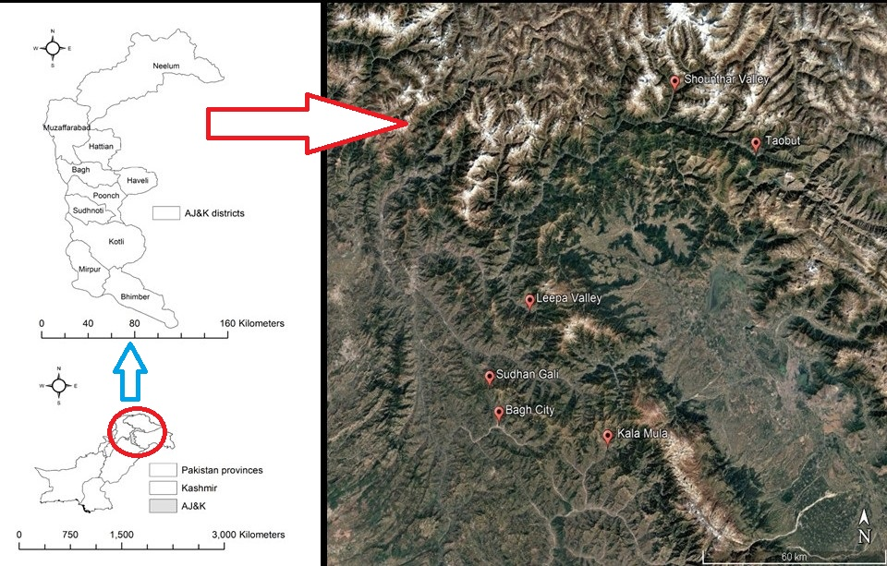

**Figure 1.** Map of the study area and location of the Potato Germplasm sampling sites in AJK**.**

**Sampling methodology:** The potato varieties were collected from a total of 5 sites including Shounthar, Taobut, Sudhan Gali, Kala Mula, and Leepa, located in 4 districts of the AJK in order to cover maximum geographical spread of the crop and record broad range of morphological traits. The data was obtained from 30 randomly selected plants at each site starting from initial growth to maturity and harvest. Repeated field surveys were conducted during 2023-24 to cover all the stages of plant growth at all the sites.

**Morphological Characterization:** The data of key morphological traits of potato varieties was acquired focusing on Plant stem, leaf, as well as tuber traits following the protocols of Chowdhury & Datta (2020); Anoumaa et al. (2023) and terrains Chourasia et al. (2023). The investigated qualitative traits included Growth Habit, Stem Color, Leaf Color, Flower Color, Tuber Shape, Tuber Skin Color, Tuber Flesh Color and Eye Depth. The quantitative traits included Plant Height, Stem Thickness, Leaf Length, Leaf Width, Leaflet Number, Flowering Time, Tuber Length, Tuber Width, Tuber thickness, and Tuber Yield per Plant.

**Data Analysis:** The data of the investigated traits from all the representative samples of varieties was tabulated to calculate average values of the parameters. The primary data was subjected to Principal Component Analysis (PCA) to identify the correlations between key traits and investigated varieties (Gower & Legendre, 1986). The data was also subjected to Cluster Analysis (CA) to reveal the most closely associated germplasm varieties based on the investigated variables.

**Results**

The morphological characterization of the potato varieties from the AJK revealed significant variations and notable diversity in the investigative traits.

**Qualitative Morphological Traits:** Kala Mula and Shounthar varieties exhibited erect **growth habit** whereas Leepa and Taobut showed semi erect habit. Sudhan Gali variety was distinct having a spready bushy form appearance. Kala Mula, Shounthar and Sudhan Gali varieties exhibited Green **stem colour** as compared to Leepa and Taobut having Purple pigmentation.

**Leaf Colour** was predominantly Dark green in all the varieties except Kala Mula variety with Light Green leaf colour. **Flower Colour** also showed variability with Leepa and Taobut Varieties having Purple, Kala Mula and Shounthar with White whereas Sudhan Gali variety having Blue Flower colour respectively. Sudhan Gali and Shounthar Varieties were characterized by round **Tuber Shape**, Leepa and Taobut with oval whereas Kala Mula variety had a distinctive elongated shape.

**Tuber Skin Colour** showed great variations with Taobut variety having red, Kala Mula Purple, Leepa and Sudhan Gali Yellow whereas Shounthar variety having white skinned tubers respectively. Shounthar, Kala Mula and Sudhan Gali had white whereas Leepa and Taobut varieties showed **Tuber Flesh Colour**. Sudhan Gali Variety was distinct characterized with maximum **Eyes Depth**, Kala Mula and Taobut had medium whereas Leepa and Shounthar varieties showed shallow eye depth respectively (Table 1).

**Table 1. The investigation qualitative morphological traits of Potato Varieties in AJK.**

|  |  |  |  |  |  |
| --- | --- | --- | --- | --- | --- |
|  | **Shounthar** | **Taobut** | **Sudhan Gali** | **Kala Mula** | **Leepa** |
| **Growth Habit** | Erect | Semi-erect | Spreading | Erect | Semi-erect |
| **Stem Color** | Green | Purple | Green | Green | Purple |
| **Leaf Color** | Dark Green | Green | Dark Green | Light Green | Green |
| **Flower Color** | White | Purple | Blue | White | Purple |
| **Inflorescence Size** | Medium | Large | Small | Medium | Large |
| **Tuber Shape** | Round | Oval | Round | Elongated | Oval |
| **Tuber Skin Color** | White | Red | Yellow | Purple | Yellow |
| **Tuber Flesh Color** | White | Yellow | White | White | Yellow |
| **Eye Depth** | Shallow | Medium | Deep | Medium | Shallow |

**Quantitative Morphological Characters**

The investigated Potato varieties exhibited an average **Plant Height** of 58.2 cm ranging from maximum value of 69.4 cm in Leepa variety to a minimum of 49.6 cm in Kala Mula. The values of **Stem Thickness** averaged 5.66 mm with the highest value of 7.3 in Leepa whereas lowest value of 4.1 in Kala Mula.

The average values of **Leaf Length** and **Leaf Width** in the varieties were recorded as 15.6 cm and 10.4 cm respectively with Leepa variety having highest values of Leaf Length as 18.1 cm and Leaf width as 12.7 cm. The varieties showed an average **Leaflet Number** of 6.8 per leaf with a highest number of 10 in Leepa whereas lowest of 5 in Kala Mula. The average number of **Flowering Time** recorded was 61 days with Taobut variety showing longest period of 68 days whereas Kala Mula with shortest Flowering period of 51 days.

The quantified Tuber dimensions showed an average **Tuber Lenth** of 8.64 cm, **Tuber Width** of 4.16 cm and **Tuber thickness** of 5.7 cm respectively with significant variation among the investigated varieties. The Potato varieties were characterized by an average Tuber Yield of 390.6 g per plant, with the highest yield of 479 g recorded in Leepa whereas lowest value of 296 g in Kala Mula variety (Table 2; Fig. 2).

**Table 2. Data of quantitative Morphological Traits of Potato varieties from AJK.**

|  |  |  |  |  |  |  |
| --- | --- | --- | --- | --- | --- | --- |
|  | **Shounthar** | **Taobut** | **Sudhan Gali** | **Kala Mula** | **Leepa** | **Average** |
| **Plant Height (cm)** | 55.1 | 63.2 | 54.1 | 49.6 | 69.4 | 58.28 |
| **Stem Thickness (mm)** | 6.9 | 5.2 | 4.8 | 4.1 | 7.3 | 5.66 |
| **Leaf Length (cm)** | 16.1 | 15.4 | 13.8 | 14.9 | 18.1 | 15.66 |
| **Leaf Width (cm)** | 11.3 | 9.5 | 8.5 | 10.2 | 12.7 | 10.44 |
| **Leaflet Number** | 8 | 6 | 5 | 5 | 10 | 6.8 |
| **Flowering Time (Days)** | 58 | 68 | 61 | 51 | 67 | 61 |
| **Tuber Length (cm)** | 9.2 | 8.2 | 8.4 | 7.3 | 10.1 | 8.64 |
| **Tuber Width (cm)** | 4.2 | 3.1 | 4.8 | 3.4 | 5.3 | 4.16 |
| **Tuber thickness (cm)** | 6.2 | 5.6 | 5.1 | 4.9 | 7.1 | 5.78 |
| **Tuber Yield per Plant (g)** | 435 | 362 | 381 | 296 | 479 | 390.6 |

**Figure 2**. Stacked chart diagram of the morphological traits of Potato germplasm from AJK.

**Data Analysis:** PCA was applied on the primary data of the quantitative traits based upon the correlation values. It explained 99.4 %variance in the data set showing the strength of the test. Leepa variety was placed distinctly along the X Axis correlated with highest recorded values for all the quantitative traits whereas Kala Mula variety was placed along Y axis with least values. The other including Shounthar, Sudhan and Gali did not show any significant correlation with the traits. However, Taobut was significantly associated with Flowering Time as reflected clearly along the x axis (Fig. 3).

**Cluster Analysis** based upon Euclidean Distance was applied on the quantitative traits to reveal significant correlations between the traits. Yield Per Plant appeared to be the most distinct traits showing its independent behavior separated from the rest of the matrix. Flowering Time and plant Height were clustered together in a group whereas the rest of the tuber and leaf traits formed a major cluster showing their strong interdependence and correlation (Fig. 4).

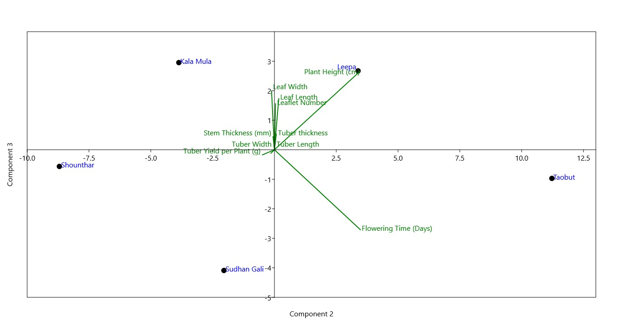

**Figure 3.** Principal Component Analysis Biplot of the investigated Potato varieties and Traits**.**

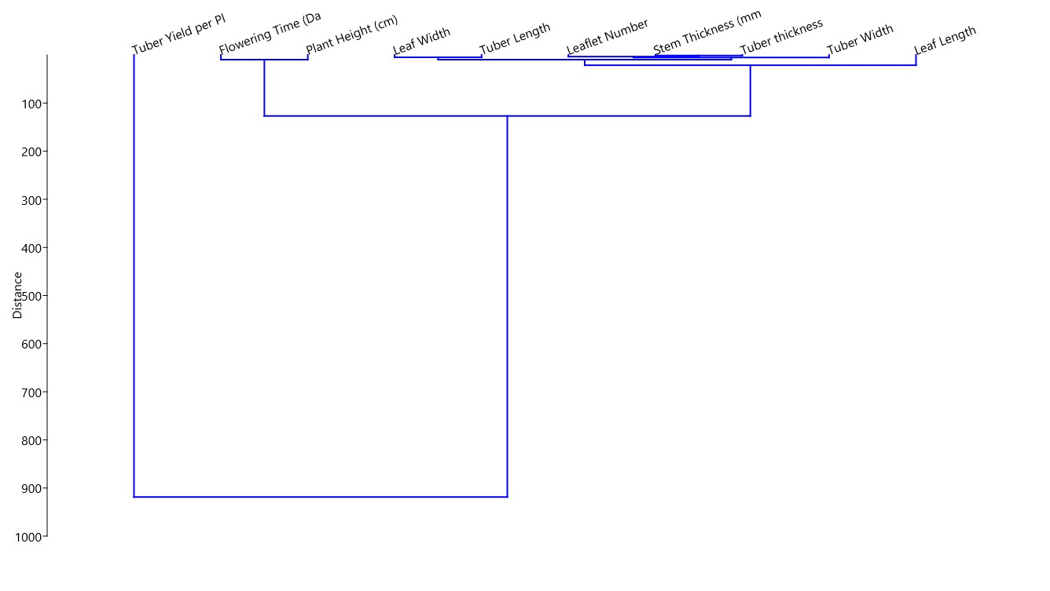

**Figure 4.** Cluster Analysis dendrogram of the quantitative morphological traits.

**Discussion**

The morphological characterization of Potato germplasm from the AJK has revealed significant levels of diversity which reflects the variability of the crop gene pool and its adaptive potential. These findings have profound implications for crop improvement and breeding programs in the Himalayan region under prevailing agroclimatic conditions.

Substantial variations in qualitative traits were recorded in the varieties. Nearly all the varieties showed erect and semi erect growth habit corresponding to the crop’s adaptive evolution as a tuber, however the Sudhan Gali variety showed bushy and scattered habit. It may be correlated with prevailing ecological conditions of the site which includes lesser solar insolation due to North aspect as well as dense tree cover around the fields which forces the branches to spread sparsely for light assimilation (Ngue et al. 2023). Stem colour variations are attributed to the accumulation of plant pigments, especially anthocyanins which result is purple pigmentation as recorded in Leepa and Taobut varieties. The anthocyanin pigmentation in stem colour is reported to enhance stress tolerance as well as plant resistance against pathogens (Lautre, 2022). Plant leaf colour is controlled by chlorophyll concentrations in the leaf tissues which is directly correlated with the amount of solar insolation (Sambo et al. 2022).

The high altitude varieties of our study including Shounthar and Taobut have shown dark green pigmentation which validates our understanding. Flower colour is another important trait that has profound impacts on plant pollination success (Likeng-Li-Ngue et al. 2023.). Investigated Potato varieties of AJK in current research have shown great variability in flower colour ranging from purple to blue as well as white. These variations reflect the inherent genetic diversity of the Potato germplasm, as well as the strategy of the plants to attract the pollinators for successful lifecycle (Arias et al. 2023). The diverse tuber colour recorded in the varieties indicates presence of secondary metabolites, especially antioxidant compounds which hold significant importance in terms of shelf life, consumer preference as well as market value of the crop. Eye depth, being the position of the perennating bud, is an important trait that affects the rate of plant regeneration. Shallower eye depth varieties show more abrupt growth initiation as compared to the deep ones, which enables early shoot growth and establishment in challenging environments of the Himalayan region (Bohórquez-Quintero et al. 2022). Shounthar and Leepa varieties exhibited shallow eye depths which indicate better growth potential of these varieties. The broad range of morphological attributes show high genetic variations in the Potato germ plasm along with indicating the adaptive potential of the varieties in diverse agroclimatic conditions (Struik & Wiersema, 1999).

Quantitative morphological attributes of the investigated Potato varieties also exhibited a wide range of variations. Plant Height showed significant variations ranging from 49.6 to 69.4 cm in our varieties reflecting the adaptability of these varieties to the diverse climatic conditions. These values are comparable with those reported by Haverkort & Struik, (2005) Taller varieties like Leepa have a better chance to compete for light (Seid & Tessema, 2021). However, shorter varieties like Kala Mula are more likely to prevail in mountainous regions having intense wind speeds, making them more resilient. Stem thickness is also correlated with the morphological strength of the plant which again showed high degree of variability. The thick stemmed plants are supposed to bear higher tuber weights (Arias et al. 2023).

Leaf Characters are very important as they determine the photosynthetic ability of the plant and subsequently the productivity and yield of the plants (Sambu, 2022). Our investigated varieties exhibited great variations in leaf size and area correlated with the diverse climatic conditions. Greater leaf area enables higher solar radiation reception and more efficient productivity of the crops. Crops in the high altitude Himalayan region having cold temperature conditions favor larger leaf sizes for better growth. Considerable variations were recorded in the flowering time of the crop in the AJK region, as high as 68 days in Taobut. The flowering period reflects the spectrum of growing conditions of any crop. The recorded flowering period is comparatively higher than the reported values of < 50 days from low altitude plain areas, as reported from several studies (Fabeiro et al. 2001). Overall, Leepa variety has been identified as the best performing and most suitable Potato variety having highest values of all the quantitative traits. On the other hand, Kala Mula variety was identified as the low performing one from the gene pool.

Tuber and yield characters are most important attributes to be considered in any crop species. The yield reflects the collective physiological performance of a species in any area. Our investigated crop potato crop showed comparable yield of 390 g per plant which is supported by the literature (Zaheer & Akhtar, 2016). This yield also enables a crop to contribute not only to the food security of a region, but also as a key resource to boost socioeconomic status and sustainable livelihood of compromised Himalayan populations. The revealed diversity of the agromorphological traits in Potato germplasm from the AJK region shows a great potential for plant breeding and crop improvement. These traits have become more important genetic resource especially in the recent context of climate change, food security and sustainable livelihood issues.

**References**

Anoumaa M, Kouam EB, Kanmegne G, Kamga YB, Sime HD, Nkombo LL & Fonkou, T. (2023). Phenotypic variation and genetic divergence studies in Cameroonian potato (*Solanum tuberosum* L.) genotypes. *Journal of Applied Biology and Biotechnology*, 11, 210-21.

Arias Z, Ortíz I, Gutarra M, Rodríguez FÁ, Gilian P, & Vilca R. (2023). Genetic and phenotypic diversity of native potatoes (*Solanum* spp.) from the Central Andes of Peru. *Acta Agronómica*, 72(1),88–96.

Arslanoglu F, Aytac S & Oner K. (2011). Morphological characterization of the local potato (*Solanum tuberosum* L.) genotypes collected from the Eastern Black Sea region of Turkey. *African Journal of Biotechnology*, 10(6), 922-932.

Bakunov AL, Dmitrieva NN, Rubtsov SL, & Milekhin AV. (2022). Characteristics of potato (*Solanum tuberosum*) genotypes for resistance to abiotic environmental stress factors. *Research on Crops*, 23(1), 126-132.

Chourasia KN, Patil VU, Vanishree G, Kumar RV, Thribhuvan R, Meena JK, Bhardwaj V. (2023). Morphological and Molecular Characterization of Indian Potato (*Solatium tuberosum* L.) Cultivars. *Cytology and Genetics*, 57(3), 246-257.

Chowdhury RS & Datta S. (2020). Characterization and Variability Studies of the Local Small Size Potato (*Solanum* sp.) Genotypes under Sub-Himalayan Foothills of India. International *Journal of Bio-resource and Stress Management*, 11(1), 27- 34.

Fabeiro C, Martin de Santa Olalla F, & de Juan JA. (2001). Yield and size of deficit irrigated potatoes. *Agricultural Water Management*, 48(3), 255-266.

GOAJK. (2019). AJK at a glance. Official Website of the Planning & Development Department, Government of Azad Jammu & Kashmir, Pakistan. <https://pndajk.gov.pk>

Gower JC, Legendre P. (1986). Metric and Euclidean properties of dissimilarity coefficients. *Journal of Classification*. 3 (1), 5–48

Haverkort AJ & Struik PC. (2005). Yield levels of potato crops: recent achievements and future prospects. Field Crops Research, 94(2-3), 251-268.

Khan MF, Tabassum N, Latif A, Khaliq A & Malik M. (2013). Morphological characterization of potato (*Solanum tuberosum* L.) germplasm under rainfed environment. *African Journal of Biotechnology*, 12(21) 3214-3223, .

Khan MH & Munir M. (2008). Evaluation of potato genotype performance under rainfed conditions in Pakistan. *Pakistan Journal of Botany*, 40(1), 33-38.

Lautre R. (2020). Profiling of Short Duration Potato (*Solanum tuberosum* L.) Hybrids and Varieties for Morphological, Yield and Quality Parameters for Chambal Region of Madhya Pradesh (Doctoral dissertation, Rajmata Vijayaraje Scindia Krishi Vishwa Vidyalaya).

Likeng-Li-Ngue BC, Ibram AM, Zenabou N, Zoa FB, Fort L, Nathalie M & Bell JM. (2023). Genetic Variability, Heritability and Correlation of Some Morphological and Yield Components Traits in Potato (*Solanum tuberosum* L.) Collections. *American Journal of Plant Sciences*, 14(9), 1029-1042.

Priyadarshini L, Samal KC, Sahoo JP, & Mohapatra U. (2020). Morphological, biochemical and molecular characterization of some promising potato (*Solanum tuberosum* L.) cultivars of Odisha. *Journal of Pharmacognosy and Phytochemistry*, 9(5),1657-1664.

Rachappanavar V. (2023). Molecular systematics and its role in cultivated *Solanum* spp. evolution. *Genetic Resources and Crop Evolution*, 70(1), 1-11.

Sambo ZC. (2022). Agro-morphological and genetic characterization of advanced potato (*Solanum tuberosum* L.) breeding lines in Mahikeng, South Africa (Doctoral dissertation, North-West University (South Africa)).

Seid E & Tessema L. (2021). Review on breeding potato (*Solanum tuberosum* L.) genotypes for processing quality traits. *Journal of Natural Sciences Research*, 12(13), 10-19.

Struik PC & Wiersema SG. (1999). *Seed potato technology*. Wageningen Academic Publishers.

Tessema L, Mohammed W, & Abebe T. (2020). Evaluation of potato (*Solanum tuberosum* L.) varieties for yield and some agronomic traits. *Open Agriculture*, 5(1), 63-74.

Zaheer K & Akhtar MH. (2016). Potato production, usage, and nutrition—a review. *Critical Reviews in Food Science and Nutrition*, 56(5), 711-721.